**Website Oriented Programming Project using ReactJs**

**( The project is based on HTML, CSS, and Javascript under Reactjs framework. )**

**Course Platform :- Simplilearn**

**Final Report**

**Topic:- Event Management System**

**Submitted by:-**

**Name:- Ashwani Kumar**

**Email ID :- ak5594137@gmail.com**

**Table Of Contents**

1.) **Introduction To Technologies** 3

2.) **Introduction To Project** 3

3.) **Objectives** 4

4.) **Theory** 4

5.) **Modules** 4

5.1.) **Log In page** 6

5.2.) **Forgot Password Page** 7

5.3.) **Home Page** 8

5.4.) **Online Transaction Page** 9

6.) **Contribution To The Project** 10

# **Introduction To Technologies**

A web project is the process of developing and creating a Web site, activities in a network which are aimed at a pre-defined goal. The network can be both accessible for everyone, as in the [Internet](https://en.wikipedia.org/wiki/Internet). The goal of Web projects is the transfer of static and dynamic content - both directly to end users, as well as indirectly through means of various kinds of interfaces. Web projects are based on [TCP/IP](https://en.wikipedia.org/wiki/TCP/IP) (Transfer Control Protocol/Internet Protocol) technology and concern the transfer of static and dynamic content.

A Web project involves many aspects, including [programming](https://en.wikipedia.org/wiki/Programming_language)and the accompanying [software](https://en.wikipedia.org/wiki/Software) development, Web business, [Web server](https://en.wikipedia.org/wiki/Web_server) and network administration, [hosting](https://en.wikipedia.org/wiki/Hosting_service), graphics/design, the development and administration of [databases](https://en.wikipedia.org/wiki/Database), construction of [interfaces](https://en.wikipedia.org/wiki/Interface_(computing)), project management and quality assurance, [search engine optimization](https://en.wikipedia.org/wiki/Search_engine_optimization), the maintenance of data in content management/editing systems and much more.

Programming for a web project may be accomplished using a markup language (such as [HTML](https://en.wikipedia.org/wiki/HTML)), scripting languages ([JavaScript](https://en.wikipedia.org/wiki/JavaScript) ), for styling our website to look to appropriate ( such as CSS ) and for complex programming ( we can use languages like C++ and Java, etc).

When hosting a Web project, the primary objectives include the provision of the necessary hardware and software infrastructure, and an assurance that the highest possible levels of availability and reliability are offered. [Web design](https://en.wikipedia.org/wiki/Web_design) for Web projects must offer a high quality of use for persons interacting with the website.

# **Introduction To Project**

**( Star Event Management System )**

Event management system is used to manage all the activity related to event. In any event, many service providers work simultaneously and it is very hard to manage these providers. To make an event successful event manager needs different service provider like Sound systems services, Lighting providers, Canteen services, stage construction and so on. In Present System, Event Company has to do all management work manually. They keep all payment information on papers. There is no system to check the past expenses on any event. To do this, they have to check payment register and This task is very time consuming and tiresome. It is also important for event organizer that he has all the contacts details of these service providers so that he can contact them any time to plan an event at given time. To manage all these activity, we have developed this website. To make an event successful event manager needs different service provider like Sound systems services, Lighting providers, Canteen services, stage construction and so on. Keeping this entire problem in mind, we have developed this system. This system helps the event management company to manage their paper work online and they can also retrieve report of last event, they have completed. To get success in the event management Sector, User should have strong network contacts of service provider. These contacts are essentially providers of specific services who can be mobilized quickly to participate in any given event. Futhermore, Event management is the application of project management to the Creation and Development of large scale events such as Festivals, Wedding Ceremonies, Formal Parties, Conference, Convocation, Anniversary Parties, and Birthday Parties, etc.... People that are need to find or book online event halls and or willing to see the packages and timing slots online about halls. They will able to get all this information easily through our website.

# **Objectives**

This web system is going to be very appraisal and advancement in Present Edition of Event Management System . System very efficiently store, maintain and retrieve data from its database and can be used for further analysis. This system provides latest notification to its user .It is going to saving the time of the user and facilitate them as per their demand. The Data in a centralized way which is available to all the event managers. It has been made easy to manage historical data in database. User can register for any happening event from anywhere and can enquire about their requirement . Furthermore Our Web System can keep records of our Users.

# **Theory**

Overall, We have to tried show function of HTML, CSS, and Javascript. We have tried to organize our text and data through HTML. We have tried to give style and texture to our website with help of CSS. We have tried to foreward the response and pop-up to the user with the help of Javascript.

In HTML, Form with it various attributes, Marquee Tag, Hover, anchor tag, link tag, etc. HTML is used to create electronic documents (called pages) that are displayed on the [World Wide Web](https://www.computerhope.com/jargon/w/www.htm). Each Page contains a series of connections to other pages called [hyperlinks](https://www.computerhope.com/jargon/h/hyperlin.htm).

This language code ensures the proper formatting of text and images so that your [Internet browser](https://www.computerhope.com/jargon/b/browser.htm) may display them as they are intended to look. Without HTML, a browser would not know how to display text as [elements](https://www.computerhope.com/jargon/h/html-element.htm) or load images or other elements. HTML also provides a basic structure of the page, upon which [Cascading Style Sheets](https://www.computerhope.com/jargon/c/css.htm) are overlaid to change its appearance. One could think of HTML as the bones (structure) of a web page, and CSS as its skin (appearance).

In CSS, We have mainly External CSS to style our Webpages. We have this language for describing the presentation of Web pages, including colors, layout, and fonts. It allows one to adapt the presentation to different types of devices, such as large screens, small screens, or printers. The combination of HTML with CSS makes it easier to maintain sites, share style sheets across pages, and tailor pages to different environments..

In Javascript, We have used various Dialog Boxes for Alert, Confirm, and Validation. We have used Client-side validation. We have used to Validate user input in an HTML form before sending the data to a server. We used to a Build forms that respond to user input without accessing a server. We have used as to Change the appearance of HTML documents and dynamically write HTML into separate Windows. We have used as to Display popup windows and dialog boxes (like alert dialog box, confirm dialog box and prompt dialog box). Displaying clocks etc.

# **Modules**

With the help of HTML (Hypertext Mark-up Language), CSS (Cascading Style Sheet), And Javascript, we have set different modules to make our project. We have made form for Log In Page though HTML. We have used different tags like Marquee Tags, Anchor Tags of HTML, External CSS, and various Pop-up and Alert text through Javascript.

**Log In page:-**

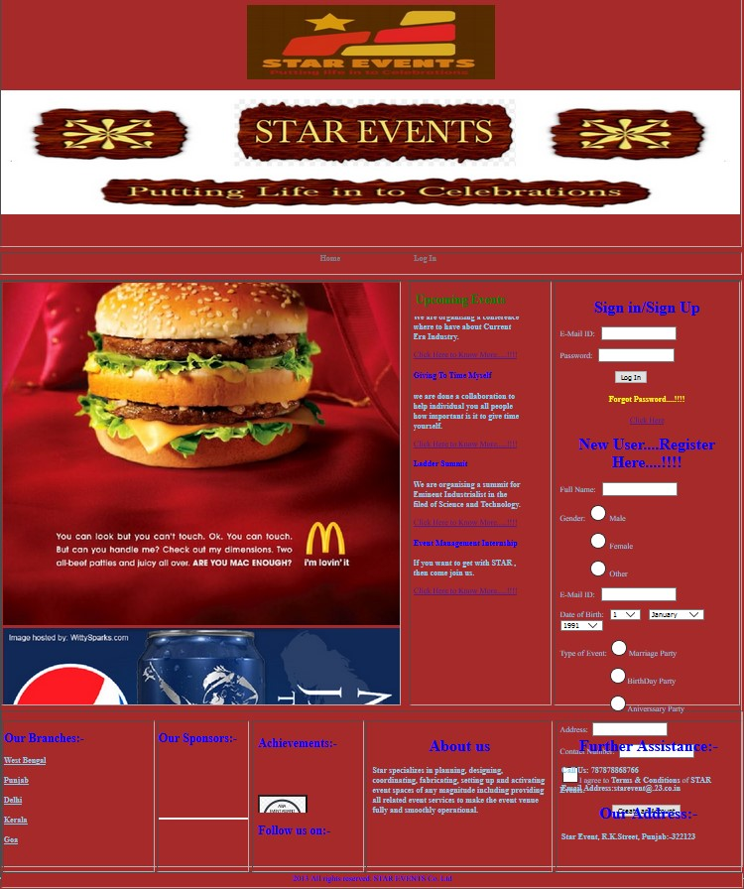

## **Forgot Password Page:-**

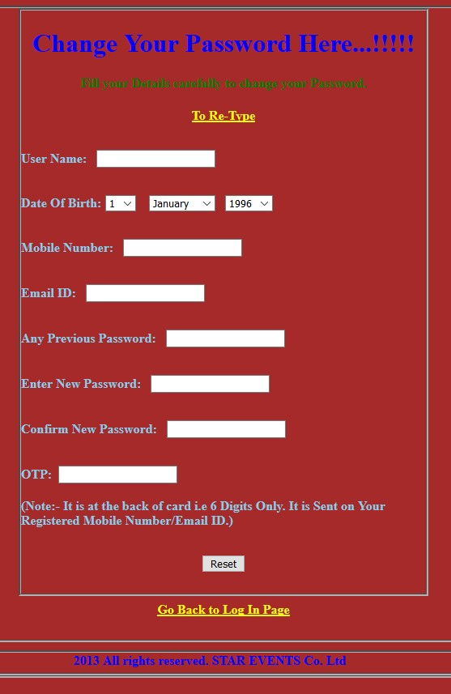

## **Home Page:-**

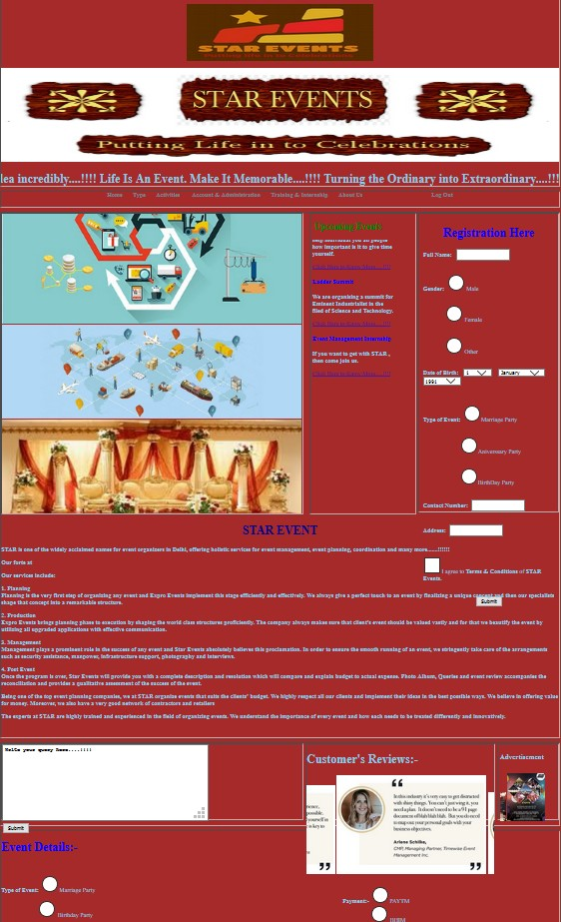

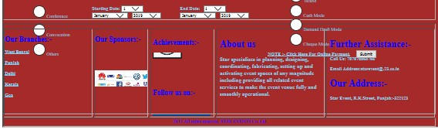

## **Online Transaction Page:-**

